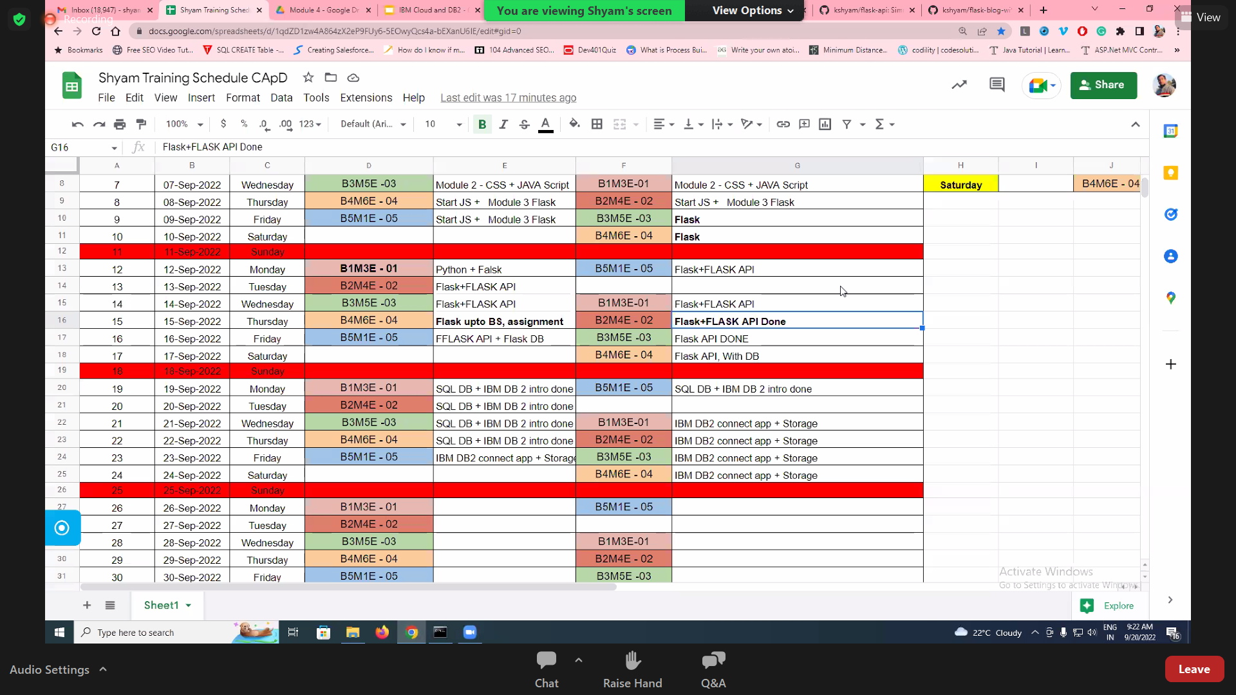

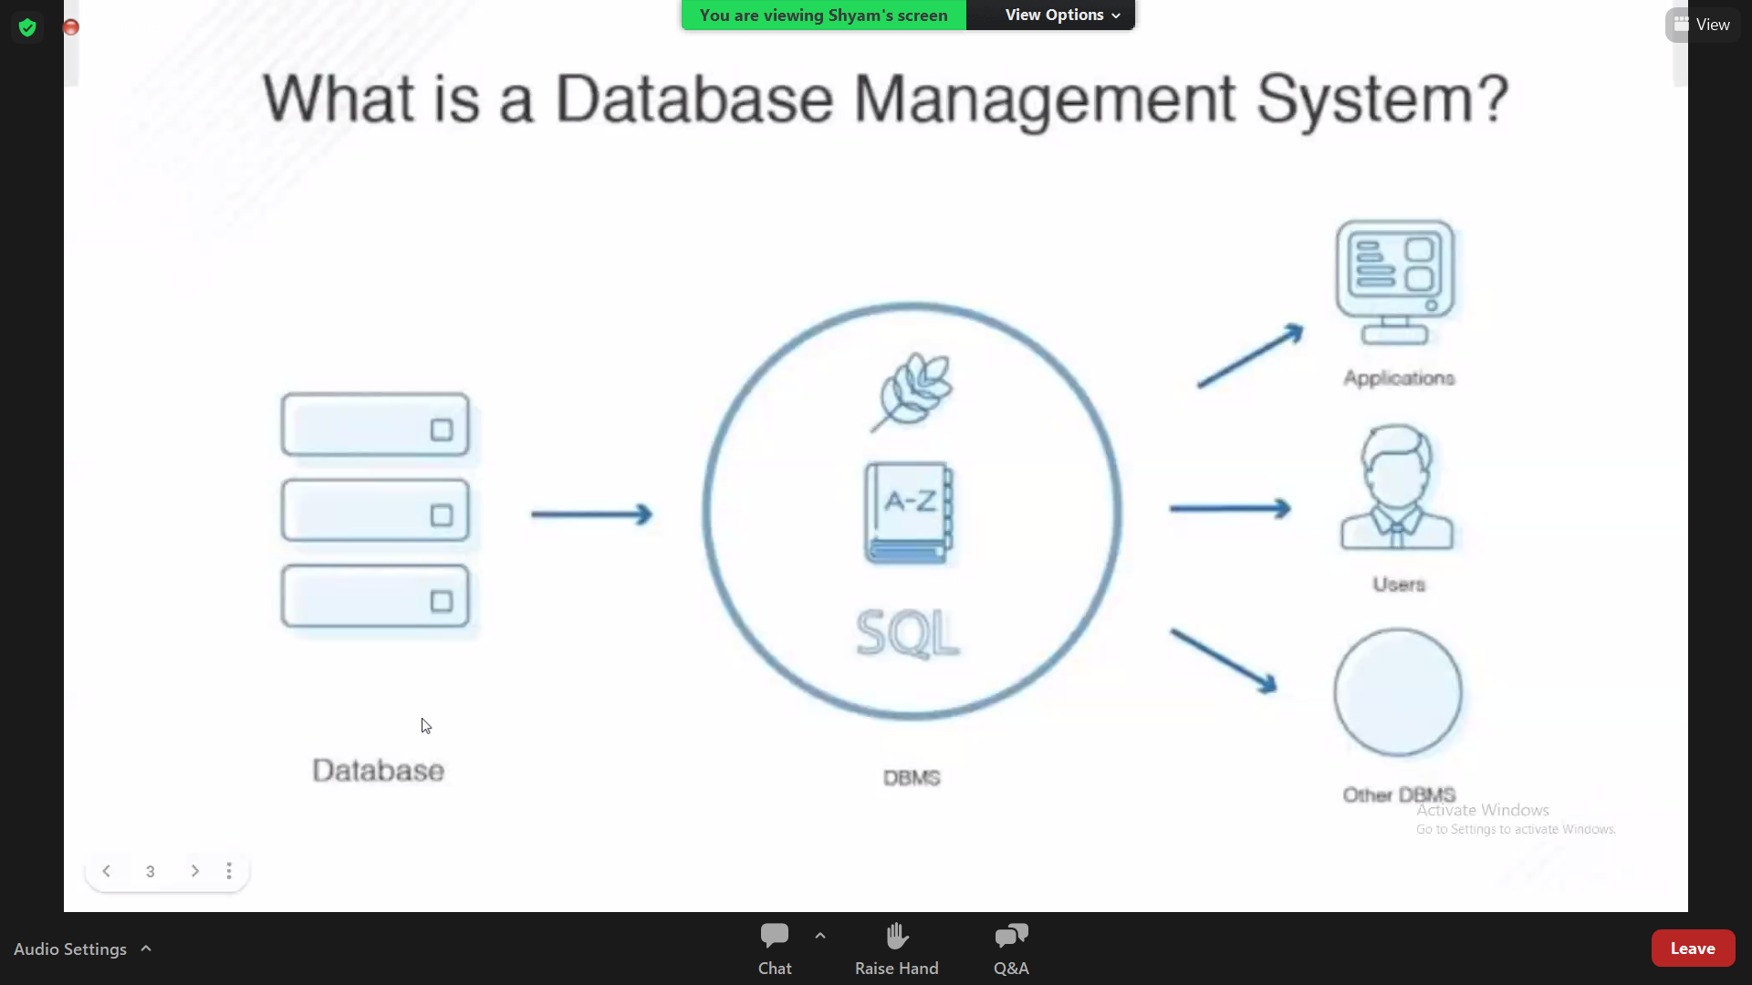

**Contents inside the table in Data Base: Planning**

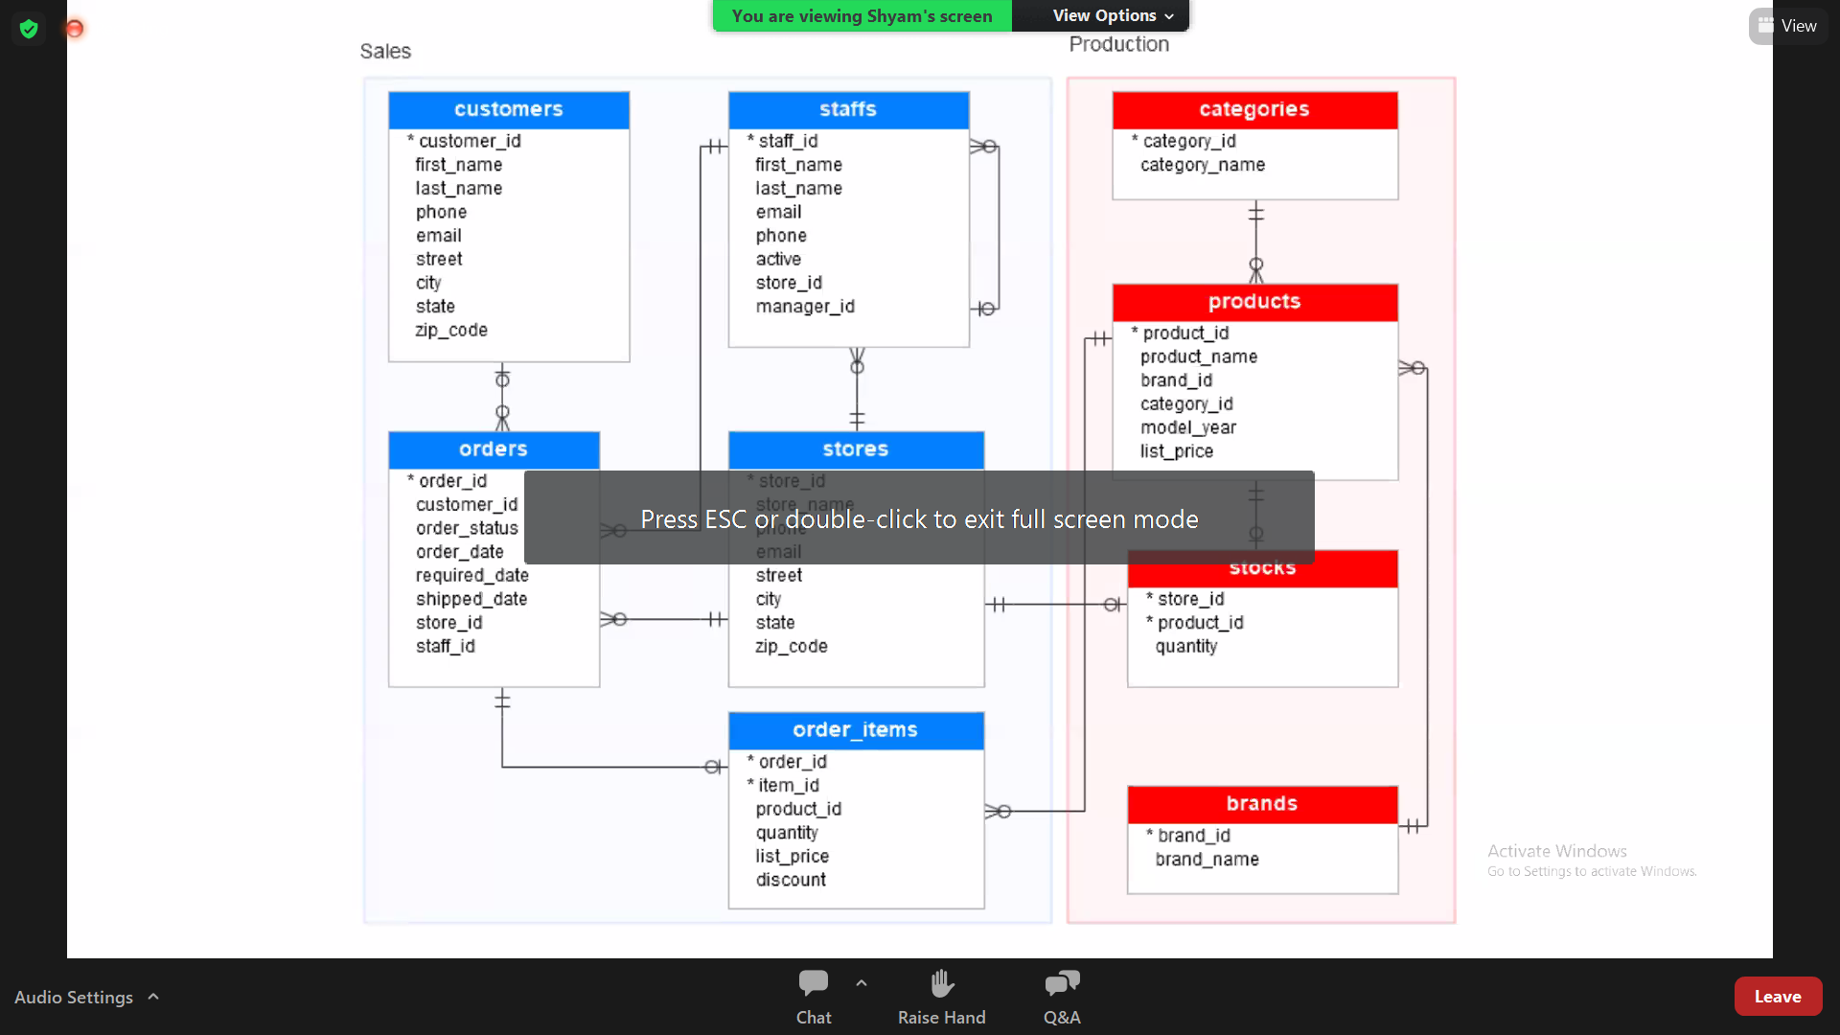

1. **W3 SCHOOL FOR SQL LESSONS**

**Link:** [**https://www.w3schools.com/sql/**](https://www.w3schools.com/sql/)

1. **GitHub links:**

[**https://github.com/kshyam/flask-with-sqlite**](https://github.com/kshyam/flask-with-sqlite)

[**https://github.com/kshyam/flask-api**](https://github.com/kshyam/flask-api)

[**https://github.com/kshyam/flask-blog-with-db**](https://github.com/kshyam/flask-blog-with-db)

1. **Presentation:**

**Link:** [IBM Cloud and DB2 - Google Slides](https://docs.google.com/presentation/d/14gU82U3nIBtAxW9LHjimZU2PqEOSVhF6ZADpUa2zuVg/edit#slide=id.g1568bcaaf87_0_5)